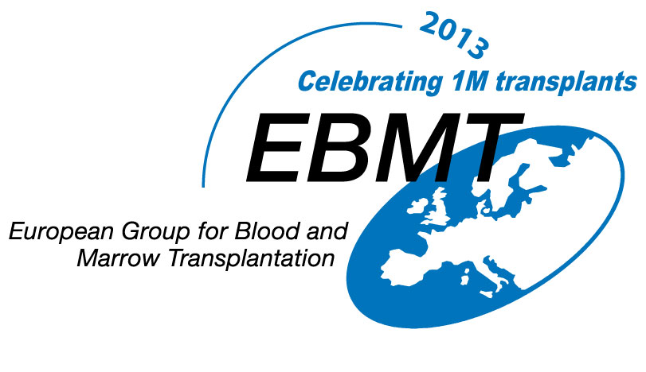
Plenary Sessions

09:00-09:45 | REGISTRATION plus TEA / COFFEE - NEWGATE ROOM
09.45- 10:00 | Welcome address from Professor Alejandro Madrigal  Session1 : Chair Professor Jane F Apperley
10:00-10:25 | What is a transplant? | Dr Kavita Raj  (London)
10:25-10:50 | How can we find the right donor at the right time? | Professor Nigel Russell,  (Nottingham)
10:50-11:15 | State of the Art: Treatment of Graft versus Host Disease | Dr Laura Jardine  (Newcastle)
11:15-11:45 | TEA / COFFEE - NEWGATE ROOM
 | Session 2: Chair Dr Maria H Gilleece
11:45-12:10 | How much will my transplant cost me? | Dr Navneet Majhail  (Minneapolis)
12:10-12:35 | Life after Transplant: Practical Challenges | Ms Suzanne Liebersbach  (Leeds)
12:35-13:00 | Life after Transplant: Psychological Challenges | Mr Philip Alexander  (London)
13:00-14:00 | LUNCH - NEWGATE ROOM
 | Session 2: Chair Professor Nigel Russell
14:00-14:25 | What’s new in transplantation? | Dr Ronjon Chakraverty  (London)
14:25-14:40 | BREAK

Afternoon Workshops / Informal discussions 14.40 - 17.30
(Details of times & rooms to follow)

Myeloma and transplant | Dr Charlotte Kallmeyer (Leeds)
Myeloproliferative Disease and Transplant | Professor Jane Apperley (London)  & Dr Maria Gilleece (Leeds)  & Dr Claire Harrison (London)
Lymphoma | Dr Steve Robinson (Bristol
Get Involved: Working with Charities | Chris Lewis (London)
ECP therapy for GVHD | Dr Peter Taylor (Rotherham)
Using the internet to get information about transplants | Dr Penny Wright (Leeds)
Sharing more than toys; how BMT affects me and my siblings | Ms Irene O’Donnell (London)
Children and adolescents ALL, SCD Thalassaemia | Dr Josu de la Fuente (London)
Acute Myeloid Leukaemia, Myelodysplasia and transplant | Dr Debbie Richardson (Southampton)
Fertility & Late Effects | Dr Nina Salooja (London)
Patient experiences | Moderator: Professor David Marks (Bristol)
RECEPTION: 17:30-18:30

